Backend Project Documentation

Project Title: Contact Manager

Team ID: 69a713cbfa5736d932f61909
Team Leader:
C. ILAKKIYA (Coding &Output)
ilakkiya06cp@gmail.com
Team Members:
Z. DHIVEYASREE (Documentation)
krishnaraj2102@gmail.com

S. ESTHERRANI (Demo video)
esther03058@gmail.com

NV. JAYADHARSHANI (PowerPoint)
dharshine47@gmail.com

K. YAMINI (Video editor)
yaminiyashni@gmail.com

1.Introduction:

- The Contact Manager System is a web-based application designed to help users store, organize, and manage their personal and professional contacts in a centralized digital platform.﻿
- Many people keep contacts across multiple platforms such as mobile phones, emails, and social media. This makes it difficult to organize and search for contacts efficiently. The Contact Manager system solves this problem by providing a structured backend system to store and manage contact information securely.
- The application is built using Node.js and Express.js for the backend and MongoDB for database storage, making it scalable, secure, and efficient.
_________________________

2. Project Overview:

- Purpose:
The main purpose of the Contact Manager system is to simplify the process of storing and managing contacts. It allows users to add, update, delete, and search contacts easily using a centralized backend application.
This system helps users organize their contacts using categories and search features, making contact management more efficient.
Key Goals:
1.Provide a centralized system to manage contacts.
2.Allow users to securely store personal and professional contact information.
3.Enable quick searching of contacts.
4.Provide secure user authentication.
5.Maintain a structured database for storing contact data.

- Features:

1.User Authentication: Users can securely register and log in to the application using email and password.
2.Contact Management: Users can add new contacts, update existing contacts, delete contacts, and view contact lists.
3.Tag Categorization: Contacts can be categorized using tags such as Family, Work, Friends, etc.
4.Search Functionality: Users can search contacts by name, email, phone number, or tags.
5.Secure Data Storage: All contact information is stored securely in the MongoDB database.

__________________________

3. Architecture:

1.Backend:
Built using Node.js and Express.js to create RESTful APIs for contact management.

2.Database:
MongoDB is used as the NoSQL database to store user and contact information.

3.Authentication:
JWT (JSON Web Token) is used to authenticate users securely.

4.Password Security:
bcrypt is used to encrypt user passwords before storing them in the database.

Backend Component Structure:
    - server/
    - App.js – Entry point of backend application
    - routes/ – API route definitions
    - controllers/ – Business logic for handling requests
    - models/ – Database schema definitions
    - middleware/ – Authentication and error handling
    - config/ – Database configuration
State Management:
    - Since this project is mainly a backend system, state management is handled through database storage and API requests.
    - Database State
    - All permanent data such as users and contacts are stored in MongoDB.
    - API Request Handling
    - Each API request retrieves or updates the database using controllers and models.
API Routing:
    - Main API routes include:
    - /register – Register a new user
    - /login – Login user
    - /contacts – View all contacts
    - /add-contact – Add new contact
    - /update-contact – Edit contact
    - /delete-contact – Delete contact
    - /search-contact – Search contacts
___________________________

4. Setup Instructions:

- Prerequisites:
Node.js (v16+)
MongoDB
Git
Visual Studio Code
Postman or Thunder Client
- Installation Steps:
1.Clone the repository:
git clone https://github.com/your-repo/contact-manager.git
2.Install backend dependencies:
cd server
npm install
3.Start backend server:
npm start

________________________

5. Folder Structure:

Contact-Manager/
│
│── server/
│ ├── controllers/
│ ├── models/
│ ├── routes/
│ ├── middleware/
│ ├── config/
│ ├── server.js
│ ├── package.json

___________________________

6. Running the Application:
- Start Backend
cd server
npm start
- Server will run at:
http://localhost:5000
___________________________

7. Component Documentation:
- Authentication:
Handles user registration and login.
- Contacts:
Allows users to create, update, delete, and view contacts.
- Search:
Allows searching contacts by name, email, phone, or tags.
- Middleware:
Handles authentication verification and error handling.

______________________

8. Database Design:
The system uses two collections.
- Users Collection
Fields:
User ID
Name
Email
Password (encrypted)
- Contacts Collection
Fields:
Contact ID
User ID
Name
Email
Phone
Notes
Tags
Relationship:
One user can have multiple contacts.
___________________________

9. User Interface:

The system can be tested using API tools .
Example actions:

      - Register user
      - Login user
      - Add contact
      - View contact list
      - Update contact
      - Delete contact
      - Search contact
________________________

10. Testing:
Testing Tools:
Postman – Testing backend APIs
Thunder Client – API request testing inside VS Code

Testing Process:
Test user registration API
Test login authentication
Test contact CRUD operations
Test search functionality
Verify database updates
_________________________

11. Known Issues:

1.No frontend interface included.
2.Requires API testing tools for interaction.
3.Limited to backend functionality.

________________________

12. Future Enhancements:
1.Frontend interface using React.js.
2.Mobile app integration.
3.Cloud database hosting.
4.Advanced contact filters.
5.Contact sharing functionality.
________________________

13. Screenshots / Demo:
1.Register API response:
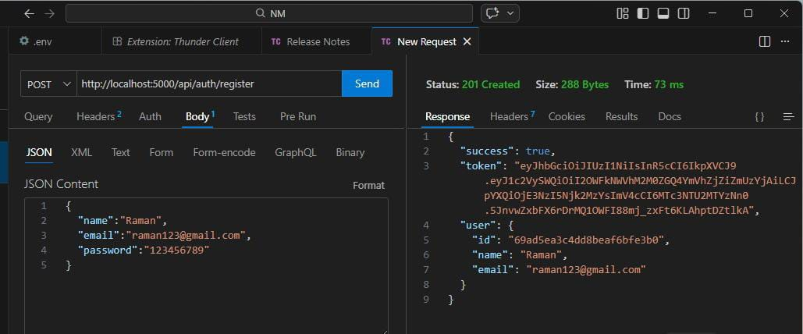

2.Login API response.
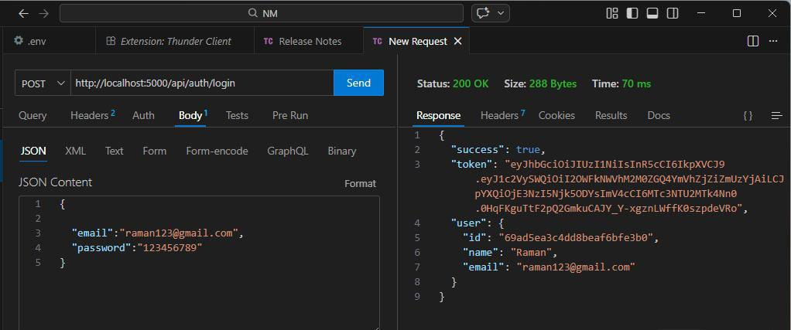

3.Create New contact:
Here we created a new contact.
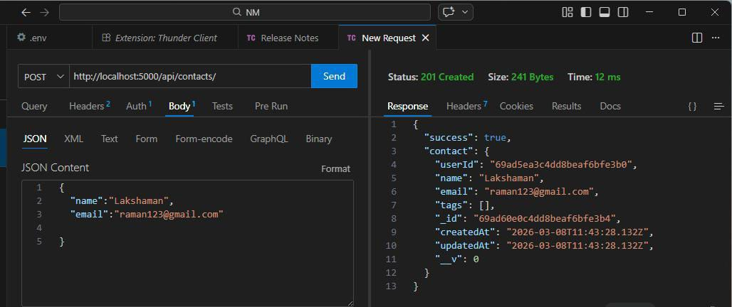

4.Add contact API response:
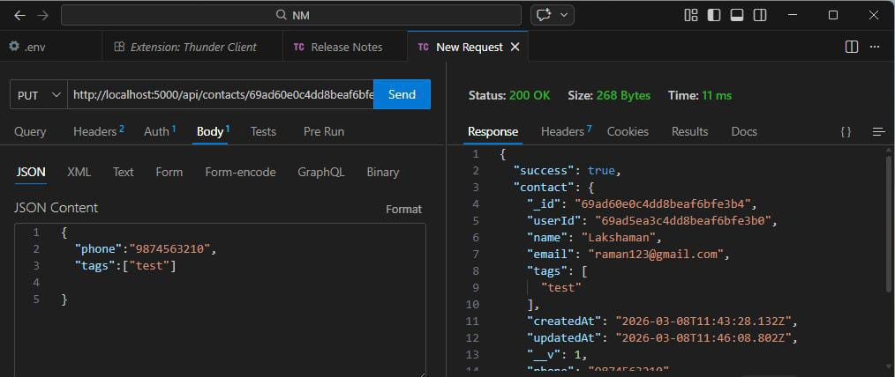

5.Delete contact API:
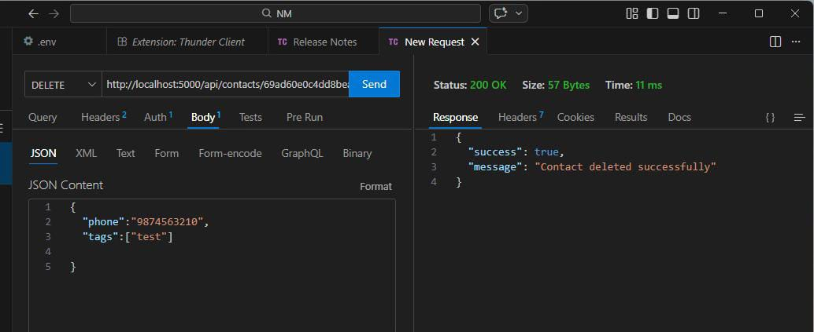

6.Search contact API response.

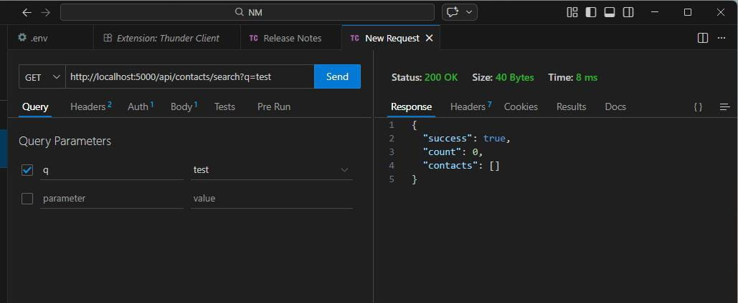

7. Get the current user:
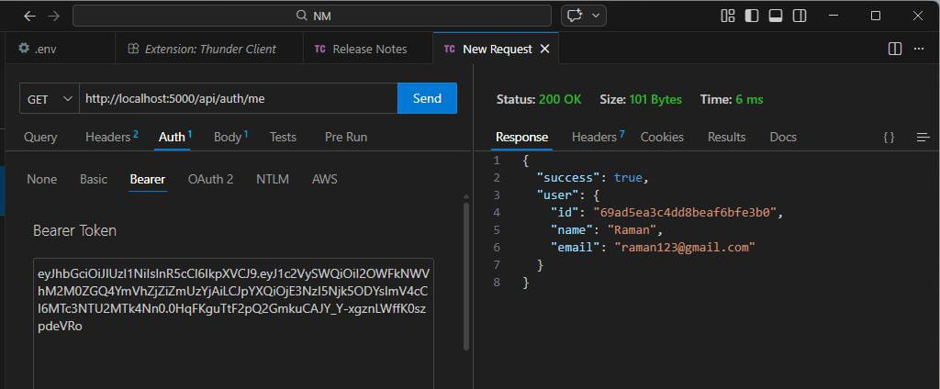

6.Demo Link:
https://drive.google.com/file/d/1zvSNIZ0LeY7a2aFCa30AesXkk-ByeGkS/view?usp=drive_link
__________________________

14. Conclusion:

1.The Contact Manager system provides a simple and efficient solution for managing contacts in a centralized database. By using Node.js, Express.js, and MongoDB, the system demonstrates modern backend development practices.
2.This project can be further expanded into a full-stack application with a frontend interface and additional features.
___________________________
THANK YOU!
___________________________

